A Study of Site Swaps:
The Mathematics of Juggling
Written by: Tyler Wallace

June 17, 2008
Masters Tutorial
University of Houston

"Like music-making, [juggling] is a common ground between the abstract form and physical dexterity; like mathematics, it is a form of pure play."
--Joe Buhler and Ron Graham
Introduction
The art of juggling has been around for centuries. The earliest record of it was found on the wall of an Egyptian tomb, dating back to 1800 BC. However, only in the past 20 years have mathematicians begun studying the pattern of juggling, how it works and what mathematics can tell us about juggling patterns. A notation for juggling patterns was developed in 1985 independently by three mathematicians: Bruce Tiemann at California Institute of Technology, Paul Klimek in Santa Cruz, and Mike Day of the University of Cambridge. This began a boom in the research of juggling patterns, also known as site swaps. The complex beauty of this field of mathematical study allows one to consider different and exciting juggling patterns. It comes as no surprise that about 40% of serious jugglers come from a mathematical background.
In this study of site swaps several different aspects of the field will be considered. This will be an elementary analysis and thus will focus only on "simple" juggling patterns. First, the notation will be studied. Once this notation is mastered one can consider many interesting mathematical questions and results from the use of this notation. Finally, this treatise on site swaps will conclude with a look at a couple extra facts on the mathematics of juggling pertaining to physics, astronomy and a bit of recreation.
Site Swap Notation
The notation of site swaps can be complex at first, but once mastered it becomes easy to translate the pattern to numbers or numbers to the pattern. Several assumptions will be made before this mathematical system is defined. Then the process of assigning numbers to define the site swap will be explained. A few special cases must be considered to complete the system. Finally, using a visual diagram, it will be explained how to create a site-swap from a known definition.
With any mathematical system that models a real world situation several assumptions have to be made. This study will focus on simple juggling, or patterns in which at most one of the balls being juggled is caught or thrown at a time. As the pattern is not dependent on the item being juggled (balls, rings, flaming arrows) the system reduces juggling to just balls. The focus will also be on the pattern in which the objects are moving between hands. Thus all throws will be treated the same (behind the back, over the head, and under the leg will all be considered equivalent). One must also assume that the juggler is working with a fixed number of balls or no balls are added or removed from the system once started. The balls will be assumed to be juggled at a constant beat. One must also assume the juggler is two-handed and alternates hands making throws. The final assumption put on the system is that the patterns are periodic. The juggler will only do one trick at a time. Most of the assumptions are common sense when considering the system to be modeled, but each is important to some part of the system.
To visualize the system mathematically, imagine a piece of music playing where one toss occurs on each beat of the music. Each toss will be assigned a number which will represent the number of beats (or length of time) the ball is in the air. Thus a ball tossed with a value of n will be in the air for n-1 tosses. Another way to consider this is a ball tossed with a value of 3 will be thrown about the height needed to juggle a cascade with three balls. A ball tossed with a value of 5 will be thrown about the height needed to juggle a cascade with five balls. Thus one finds the greater the number the higher the toss. However, it is important to note a toss of 6 is not necessarily twice as high as a toss of 3. This is because the number refers to the length of time the ball is in the air.
Combining the throw heights of all the balls together one generates a juggling pattern. The simple three ball cascade that most people learn first is done by tossing three balls between hands. Thus the ball is tossed and caught three beats apart. Joining all the balls in the periodic fashion one gets the pattern: 3 3 3.… However, the pattern is usually expressed as a fundamental period. In this case, the pattern would be written as: 3. Visually one can see the pattern on a number line starting at zero where each number represents a beat of time. One can think of the even numbers as the left hand and the odd numbers as the right hand. Through the illustration it is easy to see if a pattern is possible to juggle. If it is possible it will hit each number on the number line exactly once. One can think of this as a one-to-one and onto function. Each ball is tossed with a 3 thus it can be illustrated with a semi-circle of diameter three. The following diagram is the result which shows the location of each ball at any moment in time:
3:
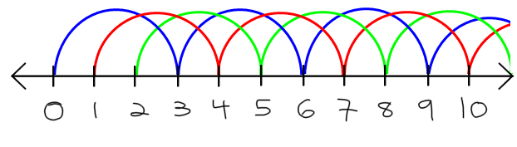
The pattern can be easily altered with different toss sizes and different number of balls where one ball is thrown to a height that one would normally be done with the five ball cascade, the next the height of the three ball cascade, the next at five balls and so on. This would generate the pattern 5 3 5 3 5 3 5… Which would be written as the fundamental period: 5 3. Later it will be explained that this pattern will need four balls to complete. Using the same process as above one can generate the following diagram from which one can note the even numbers (the left hand) is juggling as if there were 5 balls and the odd numbers (the right hand) is juggling as if there were 3 balls:
5 3:
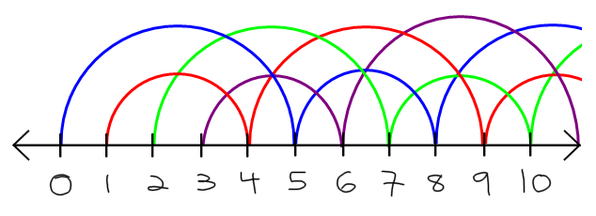
There are three special cases to the numbering system that need to be addressed: What is meant by a “swap” of 2, 1 or 0? The simple answer is a 2 represents a pause with a ball, a 1 represents a quick toss to the other hand, and a 0 represents a pause with no ball. The reasoning behind this simple answer is simple enough. Consider the ball in the right hand, a 2 is a toss of the ball while the left hand does something on the next beat. Now, two beats later the right hand again has to toss the same ball. A 2 then, is a short quick toss up, caught by the same hand, in practice the juggler usually just holds the ball for a beat. According to our assumptions, a toss of 1 will be thrown on the next beat by the other hand. Thus it is a quick transfer from one hand to the other. It does happen, given a valid juggling pattern, that a hand will be empty on a given beat. Thus there is no ball to toss. However, we have made the assumption that we alternate hands each beat. To accommodate for this a 0 is used to represent a “non-toss” on the beat in question. Thus a 0 is very much like a 2 with no ball.
These special cases can be easily seen from a few examples. Consider a 2 0: this is the exciting juggling pattern where one ball is held in one hand while the other hand is empty. Consider a 3 1: this is called the two ball shower where one ball is tossed up and the other ball is quickly transferred to the other hand. Finally consider a 4 2: this is a fountain where one hand is juggling two balls and the other hand is holding one. The following diagrams illustrate each of these patterns:
2 0:
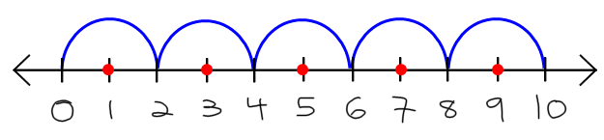
3 1:
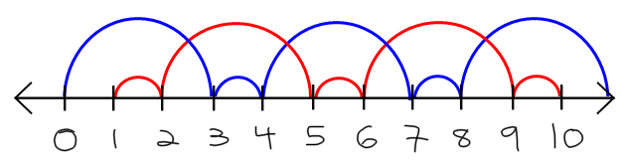
4 2:
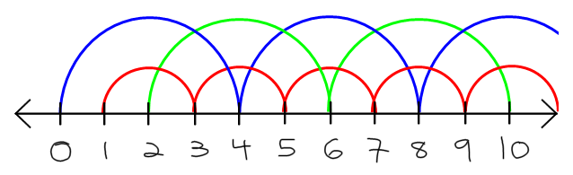
Now that the numbering system is clear, one can easily create their own pattern to be used. First start with a known pattern, for example the 3-ball cascade: 3 3 3 3 3….
3:
Next change one number in the pattern, for example: 3 3 4 3 3…
3 3 4 3 3:
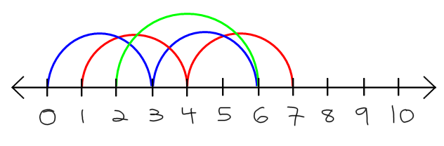
As the diagram shows, this creates two problems. First a hole is created on the number line. Second two balls collide on the same spot. The obvious solution is to take the colliding ball and adjust its height so it fills the hole. The ball that was tossed a 3 which resulted in the collision can be adjusted to a 2 and fill the hole. Now the pattern reads: 3 3 4 2 3 which will be simplified to it fundamental cycle 3 4 2, a new juggling pattern. Notice the green ball stays in the left (even) hand and the red ball stays in the right (odd) hand, while the blue ball is alternating between both hands:
3 4 2:
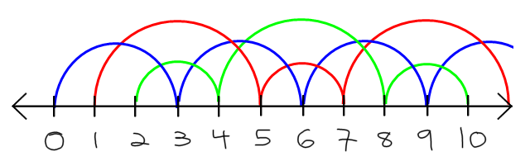
Thus in this section we have defined the assumptions necessary to investigate simple juggling site swaps. The process of defining numbers to model the system is simply done by assigning a number to each ball tossed corresponding with how long it is in the air. The special cases of a toss of 2, 1, or 0 were taken care of using logic and the assumptions on the system. With a diagram, one can visualize if a pattern is possible or create new patterns.
Mathematical Results of Site Swaps
Using this numbering system to model juggling gives rise to many interesting mathematical questions and results. First, it can be shown that the number of balls needed to juggle a pattern is equal to the average of the digits in the fundamental period. Also a permutation test can be used to test if a certain sequence can be juggled. A third result is that a simple algorithm can be used to find all possible juggling patterns given a certain length of the pattern and number of balls. Each of these is explored below.
First, several functions pertaining to the site swap notation will be defined. Consider the function j: Z → N. Let Z be the beat that a ball is tossed and let N be the height the ball is tossed at. Thus a juggling function can be expressed as j(0)j(1)j(2)… Now two other important functions will be defined:
$$MaxHeight\left(j\right)=\left\{\begin{matrix}∞ if j is not bounded \\ \max\left\{j\left(i\right)\right|i∈Z\}\end{matrix}\right.$$
$$balls\left(j\right)=number of balls in a juggling pattern$$
These functions allow the following important basic theorem:
The Average Theorem
Part 1: The number of balls needed to juggle a
juggling sequence equals the average of its digits

Part 2: Let j be a juggling function. If MaxHeight(j) is finite, then:

$$\begin{matrix}lim \\ |I|→∞\end{matrix}\frac{\sum_{i∈I}{j(i)}}{|I|}$$

Exists, is finite, and is equal to balls(j), where the limit over all the integer intervals
I={a, a+1, a+2, …, b} is a proper subset of Z, and |I|=b-a+1 is the number of integers in I

Part 1 of the theorem is an immediate consequence of part 2. Thus it will be sufficient to prove part 2. Consider an interval I such that |I| > MaxHeight(j). Then each ball must be tossed at least once in the interval. This means that balls(j) is finite. The sum of the values of j(i) corresponding to the beats $i∈I$ is bounded below by |I|+1-MaxHeight(j) and from above by |I|-1+MaxHeight(j). This implies the following inequality:
$$balls\left(j\right)(\left|I\right|+1-Maxheight\left(j\right))≤\sum_{i∈I}{j\left(i\right)}≤balls\left(j\right)(\left|I\right|-1+MaxHeight\left(j\right))$$
Dividing by |I| gives the following equation:
$$\frac{balls\left(j\right)(\left|I\right|+1-<MaxHeight\left(j\right))}{|I|}≤\frac{\sum_{i∈I}{j\left(i\right)}}{|I|}≤\frac{balls\left(j\right)(\left|I\right|-1+MaxHeight\left(j\right))}{|I|}$$
Taking the limit as |I| goes to infinity reduces to: $balls(j)≤ \frac{\sum_{i∈I}{j\left(i\right)}}{\left|I\right|}≤balls(j)$. Thus we have $balls\left(j\right)= \frac{\sum_{i∈I}{j\left(i\right)}}{\left|I\right|}$. QED
This simple theorem can be used for any site swap to determine the number of balls needed to juggle the given pattern. For example the site swap 4 5 1 4 1 requires (4+5+1+4+1)/5 = 3 balls. However, an average of an integer does not guarantee that a pattern can be juggled. It only suggests that it might be juggled. For example, consider the sequence 3 2 1. We have an average 2, but both balls would collide on beat three as shown in the diagram:
3 2 1:
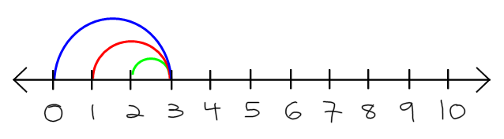
For this reason it is necessary to employ a different theorem to decide if a pattern can in fact be juggled. It turns out that if a juggling pattern were written out with several periods, and two balls are n apart in the pattern and n apart in value, a collision will occur. However, this can be tedious to check for all combinations of balls. Thus a more efficient algorithm is sought. The answer to this question lies in what will be called the fundamental theorem of site swaps.
The Fundamental Theorem of Site Swaps
A sequence a₀ a₁ a₂ … a_{n-1} of integers is a site swap for a period n juggling pattern
if and only if (a₀+0, a₁+1, a₂+2, …, a_{n-1}+n-1) (mod n) is a permutation of S_{n}.

First the Fundamental Theorem of Site Swaps will be shown by example and then secondly by a proof. Consider the possible juggling pattern 5 6 6 1 5 1, a quick calculation shows that the average, or number of balls, for the pattern is 4. Thus it might be juggling pattern for 4 balls. The fundamental theorem of site swaps gives the following calculations:
(5+0, 6+1, 6+2, 1+3, 5+4, 1+5) (mod 6) = (5, 7, 8, 4, 9, 6) (mod 6) = (5, 1, 2, 4, 3, 0) (mod 6)
As (5, 1, 2, 4, 3, 0) is a permutation of S₆, it is a valid juggling pattern as pictured below.
5 6 6 1 5 1:
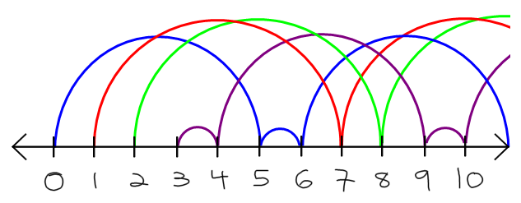
However, doing the same analysis with 5 6 1 6 5 1 yields the following result:
(5+0, 6+1, 1+2, 6+3, 5+4, 1+5) (mod 6) = (5, 7, 3, 9, 9, 6) (mod 6) = (5, 1, 3, 3, 3, 0) (mod 6)
Clearly (5, 1, 3, 3, 3, 0) is not a valid permutation of S₆, thus it is not a juggling pattern as shown in the diagram a collision occurs at point 9 and there is a hole in the graph at point 8 violating the requirement that there be a toss on each beat. Even if there were a ball there, the pattern would toss it one beat which would collide with the other two balls at 9.
5 6 1 6 5 1:
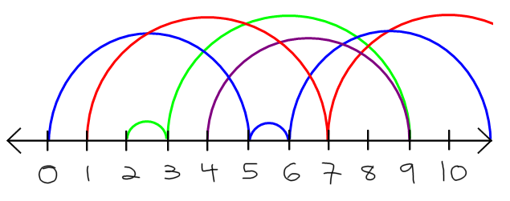
Now that the fundamental theorem of site swaps has been seen to work on two examples, it is now necessary to prove the theorem for all cases. To prove this theorem some new notation will be introduced. On the number line in our diagram, points in time have been marked: 0, 1, 2, … These will be denoted with the variable t. Thus the function f: Z → Z by
$$f\left(t\right)=\left\{\begin{matrix}x & if ball thrown at t is next thrown at x \\ t & t if their is no ball thrown at t\end{matrix}\right.$$
Thus each beat is mapped to the beat where that ball is tossed again. For example in the classic three ball cascade we have f(0)=3, f(1)=4, f(2)=5, …. Now a second function is defined: h(t) = f(t) – t. This is the height function, which yields the height of a ball thrown at time t (in truth it is not the height but the length of time or number of beats until it is thrown again).
Next it is noted that a period n juggling pattern f is a bijection such that h(t)=h(t+n). This is clear as if f(a)=f(b), then two balls are thrown at the same time, but this violates the assumption that balls are thrown one at a time. Thus a = b. Also we have assumed that a throw occurs at each beat. Thus, given a beat, there must be a ball mapped to that beat, coming from another beat to allow a throw to occur on that beat. It can be called f(t). The only exception to this pattern is if there is no ball to be thrown due to a hand being empty. We have stated that f(t) = t in this case and the point is a mapping to itself. The mapping then is a bijection based on the assumptions of the system. Now a lemma will be stated and proved that will lead to the fundamental theorem.
Lemma
If f is a period n juggling pattern and s and t are two different states, then:
s $≡$ t (mod n) implies f(s) $≡$ f(t) (mod n).
If h(t) is a periodic of period n, then the function f(t) = t + h(t) is of period n modulo n. QED.
Now there is a well-defined bijective mapping on the integers modulo n as well. For every period n juggling pattern we have a permutation of S_{n} defined by: $f\left(t\right)≡π_{f}\left(t\right)(modn)$ for 0 ≤ t ≤ n. With these tools it is now possible to prove the theorem.
→ Suppose f is a juggling pattern. Let a_{t} = h(t). Thus $f\left(t\right)≡π_{f}\left(t\right)(modn)$. By definition one has the following: $n|f\left(t\right)-π_{f}$, thus there exists an integer-valued function that will be called g(t) such that $n∙g\left(t\right)=f\left(t\right)-π_{f}(t)$ which can be rewritten $f\left(t\right)=π_{f}\left(t\right)+n∙g(t)$. This leads to the following: $a_{t}=h\left(t\right)=f\left(t\right)-t=π_{f}\left(t\right)+n∙g\left(t\right)-t$. Add t and subtract $π_{f}\left(t\right)$ from both sides gives: ${n∙g\left(t\right)=a}_{t}+t-π_{f}$ which can be written$a_{t}+t≡π_{f}\left(t\right)(modn)$, which is a permutation of S_{n} as required.
← Suppose a₀ a₁ … a_{n-1} is such that a_{t}+t (mod n) is a permutation of S_{n}. A function can be built by defining a_{t} for all integers t by extending the sequence periodically and the function f(t)=a_{t}+t. then f as defined earlier is the desired juggling pattern. It will be shown that this function is bijective. First it will be shown that it is one to one. Consider two states of the juggling pattern, t and u such that f(t)=f(u) or a_{t} + t = a_{u} + u. Then $t≡u(modn)$ as f(t) is bijective modulo n. Thus h(t) = h(u) or a_{t} = a_{u}. Combining these two statements leads to t = u. Thus the function is one-to-one.
Now it will be shown that the function is onto. Suppose $u∈Z$. Because t + a_{t} (mod n) is a permutation of S_{n}, there exists a t such that $f\left(t\right)=t+a_{t}≡u (mod n)$. Thus n | f(t) – u. or nk = f(t) – u for some integer k. By adding a suitable multiple of n, one can find a t’ such that f(t’) = u, the function is onto. Thus the function is a bijection. As stated earlier, the function being a bijection onto the number line signifies that it is a valid juggling pattern. QED
The fundamental theorem can be used easily to decide if a sequence of numbers represents a juggling pattern, however, it is most useful to the person who wants to learn a new juggling pattern by using the converse, or the second part of the “iff” statement. The fundamental theorem can be used (along with a simple algorithm) to generate all possible juggling patterns with b balls of period p. This process will be explained in general and an example given. First all the permutations of S_{p} must be calculated. The permutation can be written as a vector which shall be called P. A second vector, P’ is then calculated:
P’ = P – (0, 1, 2, … , p-1) (mod p). This step, in effect “undoes” the reduction modulo p from the fundamental theorem. The average of the entries can then be calculated and subtracted from the number of balls. A new vector is then created; it will be called Q. The entries of vector Q must add to this difference. There are obviously several possibilities for this vector and all will be listed. Next the list of juggling sequences can be created from the equation P’+pQ. In this way all possible juggling patterns can be quickly listed. The following table calculates all the possible 3- ball juggling patterns of period 3 using this method:
3-Ball Juggling Patterns of Period 3
P(ermutations of S₃) | (0, 1, 2) | (2, 0, 1) | (1, 2, 0) | (1, 0, 2) | (2, 1, 0) | (0, 2, 1)
P’ = P – (0, 1, 2) (mod 3) | (0, 0, 0) | (1, 1, 1) | (2, 2, 2) | (1, 2, 0) | (2, 0, 1) | (0, 1, 2)
3 – average(P’) | 3 | 2 | 1 | 2 | 2 | 2
Possibilities of Q | (3, 0, 0)  (0, 3, 0)  (0, 0, 3)  (2, 1, 0)  (2, 0, 1)  (1, 2, 0)  (1, 0, 2)  (0, 1, 2)  (0, 2, 1)  (1, 1, 1) | (2, 0, 0)  (0, 2, 0)  (0, 0, 2)  (1, 1, 0)  (1, 0, 1)  (0, 1, 1) | (1, 0, 0)  (0, 1, 0)  (0, 0, 1) | (2, 0, 0)  (0, 2, 0)  (0, 0, 2)  (1, 1, 0)  (1, 0, 1)  (0, 1, 1) | (2, 0, 0)  (0, 2, 0)  (0, 0, 2)  (1, 1, 0)  (1, 0, 1)  (0, 1, 1) | (2, 0, 0)  (0, 2, 0)  (0, 0, 2)  (1, 1, 0)  (1, 0, 1)  (0, 1, 1)
Juggling Sequences  (P’+3Q) | 9 0 0  0 9 0  0 0 9  6 3 0  6 0 3  3 6 0  3 0 6  0 3 6  0 6 3  3 3 3 | 7 1 1  1 7 1  1 1 7  4 4 1  4 1 4  1 4 4 | 5 2 2  2 5 2  2 2 5 | 7 2 0  1 8 0  1 2 6  4 5 0  4 2 3  1 5 3 | 8 0 1  2 6 1  2 0 7  5 3 1  5 0 4  2 3 4 | 6 1 2  0 7 2  0 1 8  3 4 2  3 1 5  0 4 5

From the above table one can count and find 37 juggling patterns with 3 balls of period 3. However, observation shows that several are the same up to a cyclic shift. Logically, one can start anywhere in the pattern and continue it indefinitely. Thus the list of 37 reduces to 13 possible unique juggling patterns. However, one in the list is not reduced to its fundamental period. The pattern 3 3 3 can be written simply as 3. Thus it does not classify as a period 3 juggling pattern, but rather a period 1. Now only 12 unique juggling patterns with three balls of period three remain:
Unique Period 3 Juggling Patterns with 3 Balls
9 0 0 | 7 1 1 | 7 2 0 | 4 5 0
6 3 0 | 4 4 1 | 1 8 0 | 4 2 3
6 0 3 | 5 2 2 | 1 2 6 | 1 5 3

The next question that comes from studying site swaps is how many unique juggling patterns exist? The calculation of such a formula is quite complex and dependent on three variables: period length (not necessarily fundamental), number of balls, and maximum height of a throw. Mathematically one may not be as interested in the last variable of height, however, to a practical juggler this variable is very important. For this discussion, however only the first two variables will be considered. Thus the following conjecture is presented.
Number of Possible Juggling Sequences
Pt 1: b ball juggling sequences of period at most p: (b+1)^{p}.

Pt 2: b ball juggling sequences of period p: (b+1)^{p}-b^{p}.

Pt 3: Unique b ball juggling sequences of
fundamental period p where d is the divisors of p:
$$J\left(b,p\right)=\frac{1}{p}\sum_{d|p}{μ\left(\frac{p}{d}\right)((b+1)^{d}-b^{d})}$$
Where $μ\left(n\right)=\left\{\begin{matrix}1 & if n=1 \\ 0 & if n is divisable by a square \\ (-1)^{v} & where n=p_{1}p_{2}…p_{v}\end{matrix}\right.$
Using the previous example with three balls and period three juggling patterns one can see the conjecture worked out. Part 1 states that there are (3+1)³ = 64 juggling patterns with three balls and period of at most 3. Part 2, which follows directly from the first part, states that there are (3+1)³ – 3³ = 37 juggling sequences with three balls of period 3 (note this is not a fundamental period). This matches the calculations in the table above.
However, part 3 is the most interesting part of the conjecture. Here an expert juggler can see how many juggling patterns he or she must master to claim to be able to juggle all possible patterns of a given length with a given number of balls. Also, here is the most complex calculation, requiring the use of an external function μ known as the Möbius function. Now the 3 ball, period 3 pattern is analyzed:
$$μ\left(1\right)=1$$
$$μ\left(3\right)=(-1)^{1}=-1$$
$$J\left(3, 3\right)=\frac{1}{3}((1)(\left(3+1)^{3}-3^{3}\right)+\left(-1\right)\left(3+1)^{1}-3^{1}\right)=12$$
As expected, the calculations confirm the work above that there are 12 unique three ball period three juggling patterns. Again, the third variable, throw height is excluded from this calculation. If a juggler could only throw balls accurately to a height of 5, then this would reduce the number of possible juggling patterns in half or six possible juggling patterns. Another note is that these calculations can get very involved when the numbers get moderately large. Thus the use of a computer is normally employed when calculating these results.
The mathematical model of site swaps has allowed mathematicians to derive many interesting results. First the number of balls needed to juggle a given juggling pattern is equal to the average of the digits. The fundamental theorem of site swaps provides a simple algorithm to conclude if a given pattern is a possible juggling pattern and to find all possible juggling patterns of a given length with a specified number of balls. A third result shows that through a simple equation one can calculate how many juggling patterns are possible with a given number of balls and a set period length. With these equations, jugglers can now easily compare and decide who is really the best juggler.

Juggling Extras
Now that site swaps and mathematical conclusions that can be made about site swaps have been thoroughly reviewed, a lighter, less mathematical study of juggling is considered. The first aspect is that of physical throw heights of the balls. A second question is then presented in an astronomical sense, does God juggle? Finally a recreational way to use site swaps is reviewed, that of juggling words and irrationals.
Mathematically it is very possible to juggle 14 or more balls. There are even several programs that can be downloaded off the internet where juggling patterns can be demonstrated with any number of balls on any given site swap. However, physics gets in the way of any practical use of this extended theory. Clearly the larger in the site swap, the higher the toss and the more accurate the juggler needs to be. To get an idea of the necessary accuracy, some estimated heights can be calculated using simple physics equations. However, as with all mathematical models, some assumptions must be made. It will be assumed that the rhythm required to juggle for an average juggler is 4 tosses per second. This also assumes that tosses take place at the same time as a catch (without this assumption, the balls would need to be tossed even higher). The following table lists how high each ball must be tossed in order to do a simple cascade of the given number of balls:
Balls | 5 | 6 | 7 | 8 | 9 | 10 | 11 | 12 | 13 | 14
Height (m) | 1.2 | 1.9 | 2.8 | 3.8 | 4.9 | 6.2 | 7.7 | 9.2 | 12.9 | 15

Several records have been set in juggling and are classified in three different categories. The first is that of flashing. Flashing is tossing and catching each ball once. The world record for flashing is 12 balls (9.2 meters high!) held by Bruce Sarafian in 1996 and Peter Bone in 2006. The second is when a juggler qualifies. This is when the juggler throws and catches each ball twice. The record for qualifying is 10 balls (6.2 meters) held by Bruce Sarafian in 2001 (he had 23 catches!). The last category for juggling records is the “more than 50 catches” category. The record for more than 50 catches is 9 balls (only tossing balls 4.9 meters high) set by Anthony Gatto in 2006. It is also interesting to note that the record for juggling (flashing) was set on rings, not balls and stands at 13, set by Albert Lucas in 2002, tossing rings with perfect accuracy at 12.9 meters in height!
Juggling can also be thought of on a much larger scale. A question in astronomy is how bodies move around each other. This has become known as the n-body problem, asking how many ways n masses can move with respect to each other in space. The mathematics of this problem is found in systems of nonlinear second-order differential equations. Here the focus will be on the results rather than the mathematics of the problem. In terms of juggling the question then becomes, do three bodies in space move about each other in a pattern that resembles a juggling pattern?
The first solution to the n-body problem was found by Euler in 1765. Euler modeled three bodies, one in the center of a circle and two others at what would be the endpoints of a diameter moving around the center object. However, it was later shown that these objects are unstable and could not possibly exist in nature. The first stable solution was found by Lagrange in 1772, a pattern that resembles a fountain juggling pattern. Here three bodies are the vertices of an equilateral triangle and rotate around a center point. The sun, Jupiter and one of the Trojan asteroids orbit one another in this manner. However, this system clearly requires that one object must be much more massive than the other two. Thus, in this case it is clear that God can juggle the three ball fountain.
But does he do the cascade? Or is that to simple that he has left it for humans to enjoy? Recently Cristopher Moore, Alain Chenciner and Richard Montegomery found a solution to the 3-body problem that resembles the three ball cascade. The solution is a model and no such system has been found yet. However, it has been shown that in the universe such a system can exist. The three body cascade has been shown to be much more stable than any other nontrivial solution to the n-body problem. It has also been shown that the three objects would have to be similar in mass for the system to exist. Experiments by Douglass Heggie from Edinburgh University suggest that there may actually be three suns in our universe that follow the cascade pattern. The probability for such an occurrence is placed between “one in one galaxy to one in one universe.” Does God juggle the cascade? Who knows, but if he does, he doesn’t do it very often!
As this discussion on site swaps comes to a close, one last thing needs to be addressed. Up until this point all tosses have been 9 or under. This is to avoid confusion with the pattern 4 2 and the number 42. When a toss is of greater value than a 9 a letter is assigned to it starting with A (10), then B (11) and so on. Thus the simple notation can extend out to 36 different heights (0 – Z). Now that letters are also included in the site swap notation, the question of whether or not a word can be juggled is the next step to be considered. Many people try to juggle apples, and the word APPLE can also be juggled, requiring (10+25+25+21+14)/5 = 19 balls. This can be verified using the fundamental theorem:
$$\left(10+0, 25+1, 25+2, 21+3, 14+4\right)=\left(10, 26, 27, 24, 18\right)≡\left(0, 1, 2, 4, 3\right)(mod 5)$$
This is a permutation of S₅.
Using this method a person can find many interesting results. For example it takes 21 balls to juggle THEOREM, and 23 balls to juggle PROOF. Clearly the THEOREM is easier than the PROOF, but any mathematician knew that before anyone studied site swaps. Ironically the world JUGGLE cannot be juggled. The fundamental theorem shows:
$\left(29+0, 30+1, 16+2, 16+3, 21+4, 14+5\right)=\left(29, 31, 18, 19, 25, 19\right)≡\left(5, 1, 0, 1, 1, 1\right) (mod 6)$.
Clearly this is not the desired permutation.
The next question a mathematician has to consider is if their name can be juggled. TYLER run through the fundamental theorem yields the following:
$(29+0, 34+1, 21+2, 14+3, 27+4)=(29, 35, 23, 17, 31)≡4, 0, 3, 2, 1 (mod 5)$.
Thus TYLER is a juggling pattern requiring 25 balls. This is a logical conclusion as I was born on the 25th day of the month. However, WALLACE is not a valid juggling pattern.
Another interesting test is that of irrational numbers such as e and π. How long can an irrational number be juggled? To juggle an irrational number each toss is equal to the next digit in the number. If there is no ball to toss, a new ball is added to the system and tossed the desired height. Thus the number e can be tested as shown in the following diagram:
e = 2.71828182845904523536…
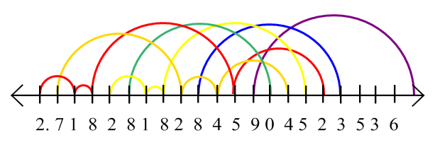
The number e can be juggled all the way out to the 14th digit before a zero throw occurs. According to the rules of the system a 0 is a beat where no ball is thrown due to a hand being empty. But the diagram shows the green ball should be thrown on this beat. Even if the ball were allowed to drop out of the system at this point, five digits later several balls would be colliding. However, to the merit of the number e, there are 14 tosses occurring with a total of 6 balls before any problems occur, which is better than most jugglers. The number π is not quite as exciting:

π = 3.14159265358979…
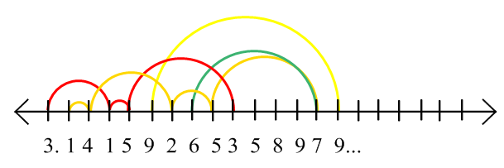
The 8th and 9th beat collide with each other. Thus π can only juggle 4 balls for 8 beats. In a very similar fashion any irrational number can be studied.
Site swaps takes on a whole new perspective through the lens of physics and astronomy. Physics limits the actual use of site swaps to realistic application of a limited number of balls and height. Astronomy suggests that heavenly bodies may in fact be moving in a juggling pattern as God juggles the planets, stars, and moons. Or, site swaps can just be used for the recreational enjoyment of knowing what words or names can be juggled, or even if irrationals can be juggled. Clearly the use of site swaps can be seen in many different avenues.
Conclusion
The field of site swaps begins to take a much more complex view when assumption begin to be removed such as allowing for the catching or throwing of more than one ball at a time. However, this elementary introduction to the field covered many different areas. First the notation of site swaps was introduced, turning a juggling pattern into a string of numbers. By careful use of this notation several conclusions were made. The number of balls to juggle a pattern is equal to the average of the numbers in the site swap. To decide if a pattern is possible to juggle, one simply uses the fundamental theorem looking for a permutation. Then to conclude, several other aspects of site swaps were considered including the physics of throw heights and the astronomy of God juggling the heavenly bodies. Finally it was shown how recreationally site swaps can show if juggling words or irrationals is possible. What conclusions can now be made? Being able to juggle does not require knowledge of the math. Knowing the math does not imply one can juggle. But knowing both opens up a wide world of possibilities.
References
Beek, Peter and Arthur Lewbel. “The Mathematics of Juggling.” The Science of Juggling.
http://www.juggling.org/papers/science-1/mathematics.html (accessed June 9, 2008).

Buhler, Joe and Ron Graham and Colin Write. “Juggling Drops and Descents.” The American
Mathematical Monthly Vol. 101, No. 6, (Jun.-Jul. 1994): 507-519.

Burger, Keven. “Read This: The Mathematics of Juggling.” MAA Online.
http://www.maa.org/reviews/mathjuggling.htm (accessed June 9, 2008).

Darley, Vincent. “Site Swaps: Examples.” Juggling Information Services.
http://www.juggling.org/help/siteswaps/examples.html (accessed June 9, 2008).

“JIS Numbers Juggling Records” Juggling Information Services.
http://www.juggling.org/records/records.html (accessed June 15, 2008).

Knutson, Allen. “The Mathematics of Juggling.” University of California, San Diego. http://math.ucsd.edu/~allenk/Roma2008/r.pdf (accessed June 15, 2008).

Knutson, Allen. “Siteswap FAQ.” Juggling Information Service.
http://www.juggling.org/help/siteswap/faq.html (accessed June 9, 2008).

Morgan, Alan. “Siteswaps for the Masses.” Juggling Information Service.
http://www.juggling.org/help/siteswap/masses.html (accessed June 9, 2008).

Naffziger, Charlie. “Juggling and Math?” Lecture, Central Oregon Community College, ORMATYC
Conference, April 24, 2008.

Peterson, Ivars. “Juggling by Design.” MAA Online.
http://www.maa.org/mathland/mathtreck_8_2_99.html (accessed June 9, 2008).

Polster, Burkard. The Mathematics of Juggling. New York: Springer-Verlag, 2003.

Wright, Colin and Andrew Lipson. “SiteSwaps: How To Write Down a Juggling Pattern: A Guide for the
Perplexed.” Solipsys Ltd. http://www.juggling.org/help/siteswap/ssintro (accessed June 9, 2008).

Buhler, Joe and Ron Graham and Colin Write. “Juggling Drops and Descents.” The American Mathematical Monthly Vol. 101, No. 6, (Jun.-Jul. 1994): 507-519.
Peterson, Ivars. “Juggling by Design.” MAA Online. http://www.maa.org/mathland/mathtreck_8_2_99.html (accessed June 9, 2008).
Beek, Peter and Arthur Lewbel. “The Mathematics of Juggling.” The Science of Juggling. http://www.juggling.org/papers/science-1/mathematics.html (accessed June 9, 2008).
Also known as siteswaps or site-swaps.
Burger, Keven. “Read This: The Mathematics of Juggling.” MAA Online. http://www.maa.org/reviews/mathjuggling.htm (accessed June 9, 2008).
Wright, Colin and Andrew Lipson. “SiteSwaps: How To Write Down a Juggling Pattern: A Guide for the Perplexed.” Solipsys Ltd. http://www.juggling.org/help/siteswap/ssintro (accessed June 9, 2008).
A cascade is when balls are tossed from one hand to the other each toss about the same height.
Morgan, Alan. “Siteswaps for the Masses.” Juggling Information Service. http://www.juggling.org/help/siteswap/masses.html (accessed June 9, 2008).
Beek, “The Mathematics of Juggling”.
Morgan, “Siteswaps for the Masses”.
Ibid.
Write, “Siteswaps: How to Write Down a Juggling Pattern: A Guide for the Perplexed”.
Ibid.
Ibid.
Knutson, Allen. “Siteswap FAQ.” Juggling Information Service. http://www.juggling.org/help/siteswap/faq.html (accessed June 9, 2008).
A shower is when the balls move in a circular pattern through the hands.
Ibid.
A fountain is when the balls in each hand shoot up and back down to the same hand.
Ibid.
Write, “SiteSwaps: How to Write Down a Juggling Pattern: A Guide for the Perplexed”.
Polster, Burkard. The Mathematics of Juggling. New York: Springer-Verlag, 2003, 14.
Ibid., 15.
Ibid., 16.
Peterson, “Juggling by Design”.
Morgan, “Siteswaps for the Masses”.
Naffziger, Charlie. “Juggling and Math?” Lecture, Central Oregon Community College, ORMATYC Conference, April 24, 2008.
Peterson, “Juggling by Design”.
Ibid.
Buhler, “Juggling Drops and Descents”.
Ibid.
Ibid.
Ibid.
Polster, The Mathematics of Juggling, 24.
Ibid., 25 (with corrections).
Naffziger, “Juggling and Math?”.
A proof of the Number of Possible Juggling Sequences conjecture can be found in Polster The Mathematics of Juggling, 38.
Polster, The Mathematics of Juggling, 40.
Naffziger, “Juggling and Math?”.
Polster, The Mathematics of Juggling, 131.
Burger, “Read This: The Mathematics of Juggling”.
“JIS Numbers Juggling Records” Juggling Information Services. http://www.juggling.org/records/records.html (accessed June 15, 2008).
Burger, “Read This: The Mathematics of Juggling”.
“JIS Numbers Juggling Records”.
Ibid.
Ibid.
This discussion will limit to 3 dimensional space, however, the n-body problem is concerned with n-space
Polster, The Mathematics of Juggling, 178.
Ibid.
Ibid., 179.
Ibid., 180.
Morgan, “Siteswaps for the Masses”.
Polster, The Mathematics of Juggling, 190.
Ibid.
Ibid.
Ibid., 191.
Ibid.
Ibid.

